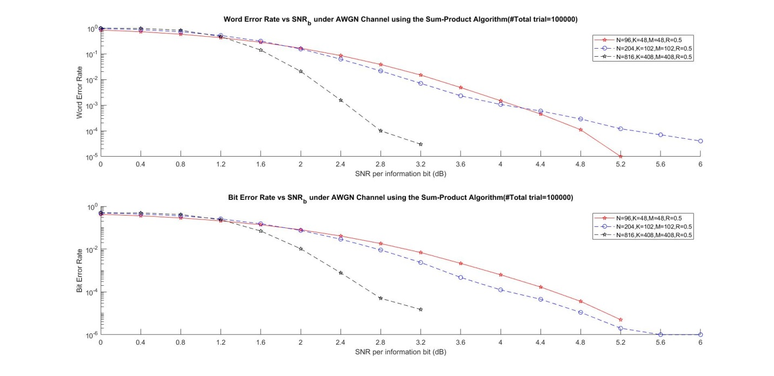

BER & WER Performance using different LDPC codes under ***AWGN*** Channel

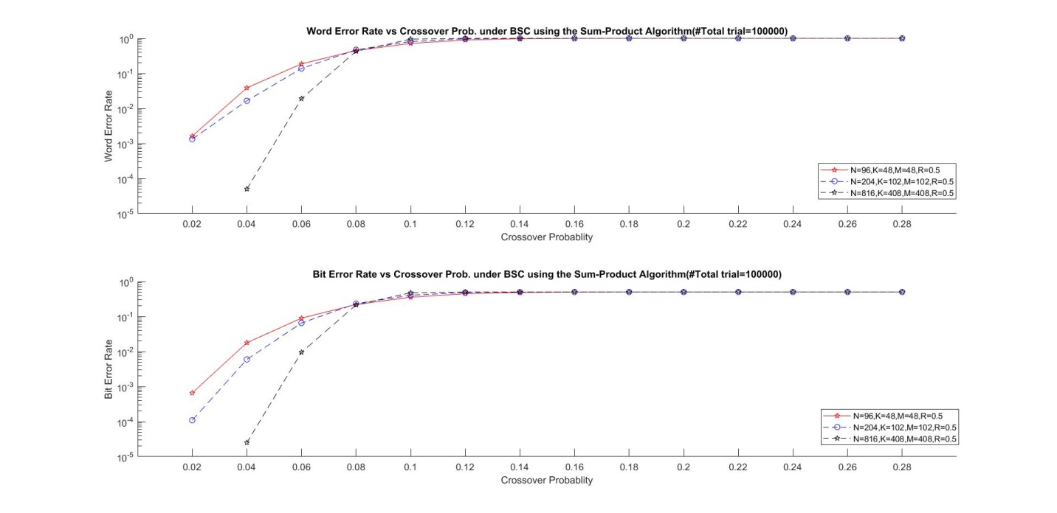

BER & WER Performance using different LDPC codes under ***BSC***

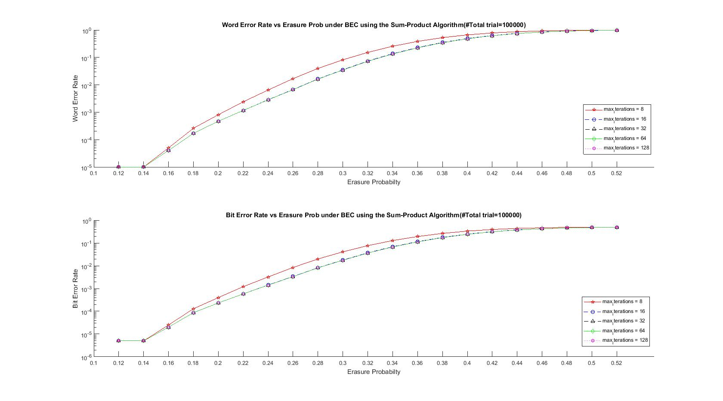

BER & WER Performance using (96.3.963 (N=96,K=48,M=48,R=0.5)) codes under ***BEC***

with different max_iterations

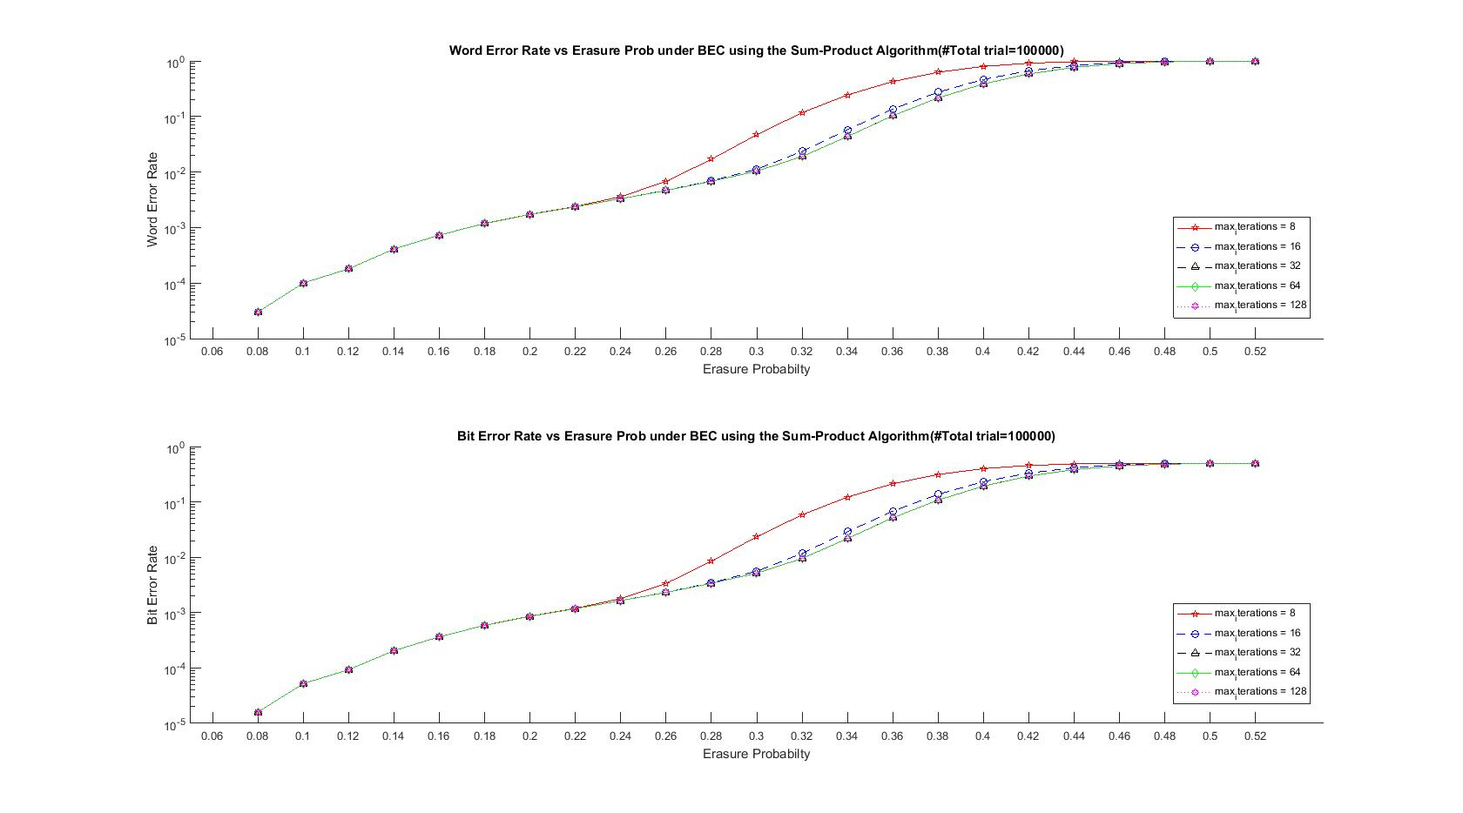

BER & WER Performance using (204.33.486 N=204,K=102,M=102,R=0.5) codes under ***BEC***

with different max_iterations

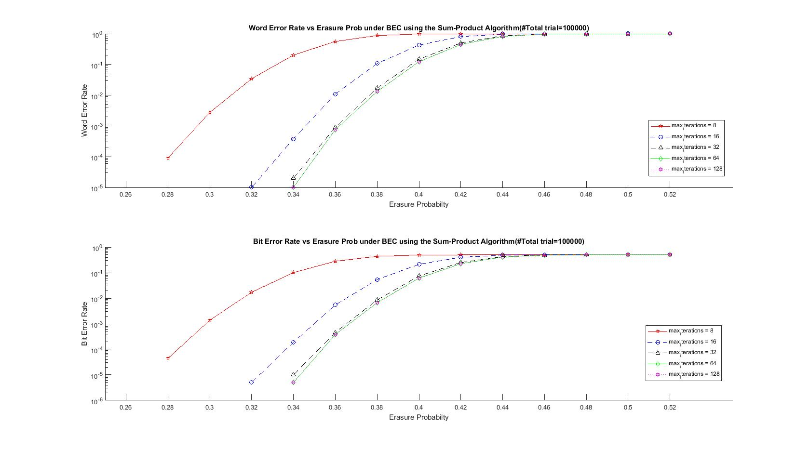

BER & WER Performance using (816.3.174 (N=816,K=408,M=408,R=0.5)) codes under ***BEC***

with different max_iterations